Ron Nasti Spirit Award
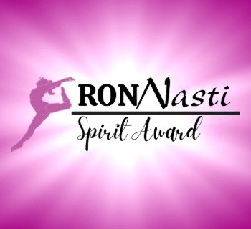
Ron Nasti was an important influence in the sport of Gymnastics during his long career as a champion athlete, business owner, and Illinois State Board member.
The purpose of the Ron Nasti Spirit Award is to give a yearly scholarship to a gymnast who exemplifies the spirit of hard work, hope and unity to their team as well as themselves. The recipient of this scholarship is a genuine leader who exemplifies diligence, respectfulness, and outstanding team spirit. This is a monetary scholarship for $1,000 to be awarded to a graduating senior attending college.
Nominate a gymnast today!!
The Ron Nasti spirit Award recipient must be nominated by a coach who sees these qualities in their athlete. There is a form to be filled out and submitted to:
gymphenom@sbcglobal.net
NO LATER THAN APRIL 15TH

Ron Nasti Spirit Award Application
Club name:
Club Address: Club phone:
Club e-mail contact:
Coach name: Coach USAG#
Coach Contact info:

Athlete name: USAG#
Athlete address:
Athlete parent contact info:

Why is this athlete being nominated?

Does this athlete possess all the qualities the award requires? How?

Coach Signature:

